SQL QUERIES

CREATE DATABASE company;
USE company;
CREATE TABLE employee (
emp_id INT PRIMARY KEY,
emp_name VARCHAR(50),
department VARCHAR(50),
salary INT,
);

INSERT INTO Employee (id, ename, department, salary)
VALUES
(1, ‘john’, 'HR', 1000),
(2 ‘siya, 'Finance', 22000),
(3, ‘Ram’, 'HR', 1000),
(4 'Riya', 'Finance', 22000),
(5, ‘Shyam’, 'HR', 1000),
(7 'Priya', 'Finance', 22000),
(8, ‘Rohan’, 'HR', 1000),
(9 'Neha', 'Finance', 22000),
(10, ‘Samu’, 'HR', 1000),
(11 ‘Raghav’, 'Finance',35000),

SELECT * FROM employee;

1.Create Table and Database:

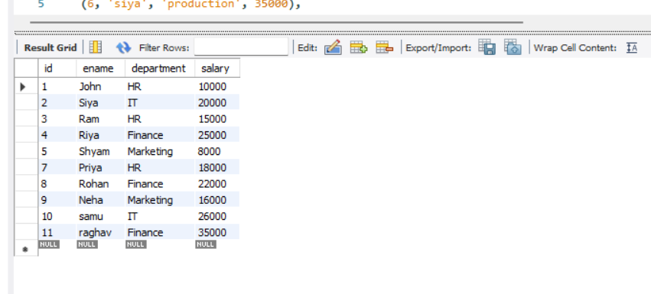

2. Top 5 highest salary employees:

SELECT *
FROM Employee
ORDER BY salary DESC
LIMIT 5;

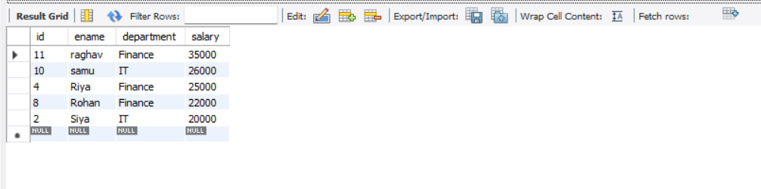
3.Department wise employee count:

SELECT department, COUNT(*) AS employee_count
FROM Employee
GROUP BY department;

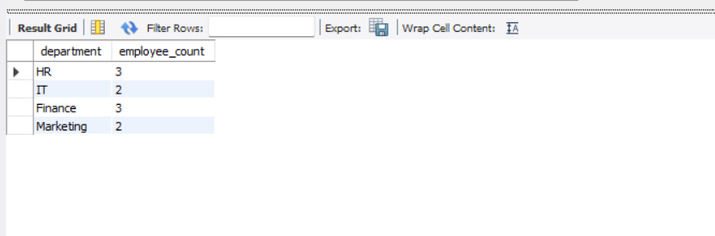

4.Find second highest salary:
SELECT MAX(salary) AS second_highest_salary
FROM Employee
WHERE salary < (SELECT MAX(salary) FROM Employee);



5.Employee whose salary > department average salary:

SELECT e.*
FROM Employee e
WHERE e.salary >
(
SELECT AVG(salary)
FROM Employee
WHERE department = e.department
);

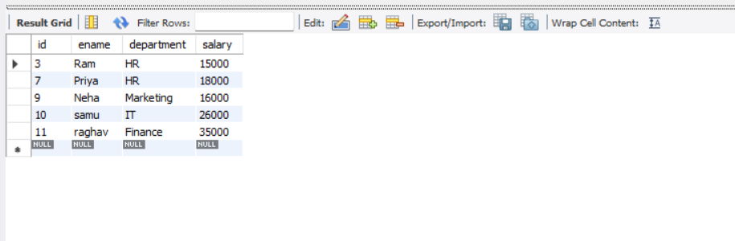

Creating another table for inner join;
Department table:
CREATE TABLE Department (
id INT,
department VARCHAR(50)
);

INSERT INTO Department VALUES
(1, 'HR'),
(2, 'IT'),
(3, 'Finance'),
(4, 'production'),
(5, 'HR'),
(7, 'IT'),
(8, 'Finance'),
(9, 'production'),
(10, 'HR'),
(11, 'marketing');
SELECT * FROM department;

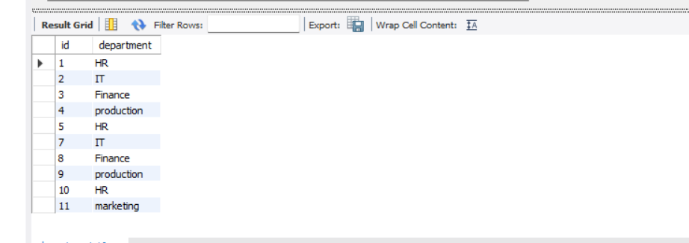

6.inner join:

SELECT
e.id,
e.ename,
d.department
FROM Employee e
INNER JOIN Department d
ON e.id = d.id;

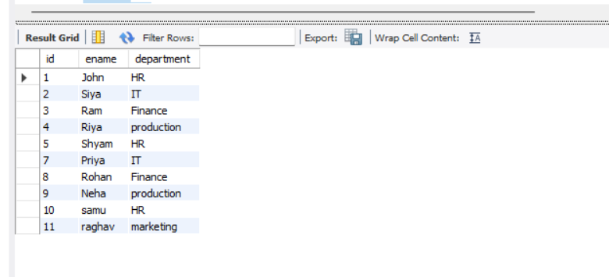

7.Left join;
SELECT
e.id,
e.ename,
e.salary,
d.department
FROM Employee e
LEFT JOIN Department d
ON e.department = d.department;

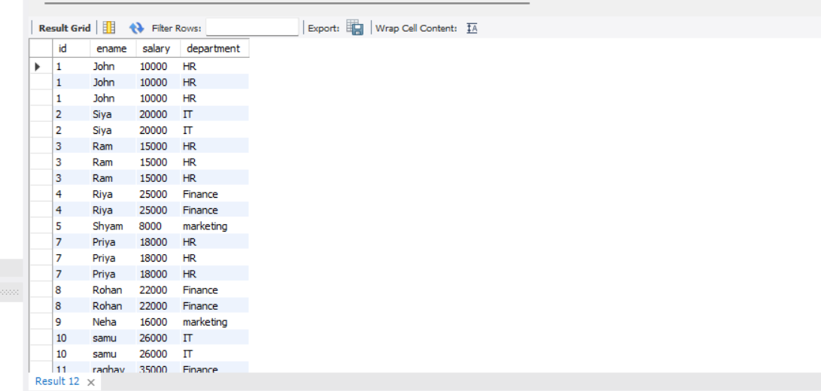

8.Group by with having:

SELECT department, COUNT(*) AS employee_count
FROM Employee
GROUP BY department
HAVING COUNT(*) > 1;

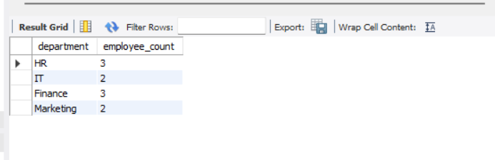

9.Employees hired in last 6 months:
SELECT *
FROM Employee
WHERE joining_date >= DATE_SUB(CURDATE(), INTERVAL 6 MONTH);

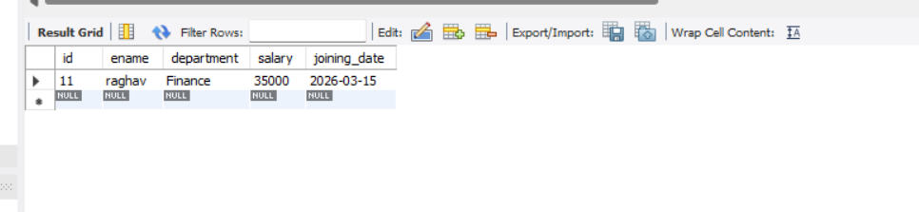

10.Find duplicate records:

SELECT department, COUNT(*) AS cnt
FROM Employee
GROUP BY department
HAVING COUNT(*) > 1;

